FOCP C Programming Assignment
Module 2: Conditional Statements and Operators
Question 5: FizzBuzz
Platform: HackerRank
Programming Language: C
Problem Link: https://www.hackerrank.com/challenges/fizzbuzz/problem
Problem Statement:
Write a program that prints each number from 1 to 100 on a new line.
The following conditions must be followed:
- For multiples of 3, print Fizz instead of the number.
- For multiples of 5, print Buzz instead of the number.
- For multiples of both 3 and 5, print FizzBuzz.
- For all other numbers, print the number itself.
Input Format
No input is required.
Output Format
Print the numbers from 1 to 100, following the FizzBuzz rules, with each result on a new line.
Source Code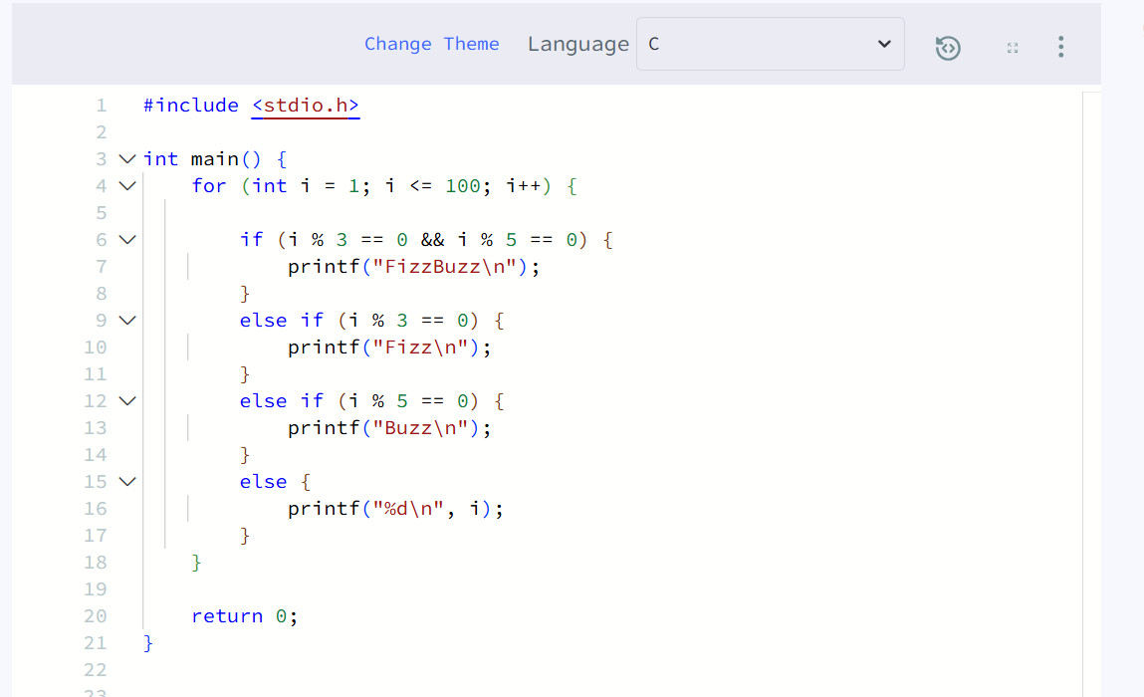Output
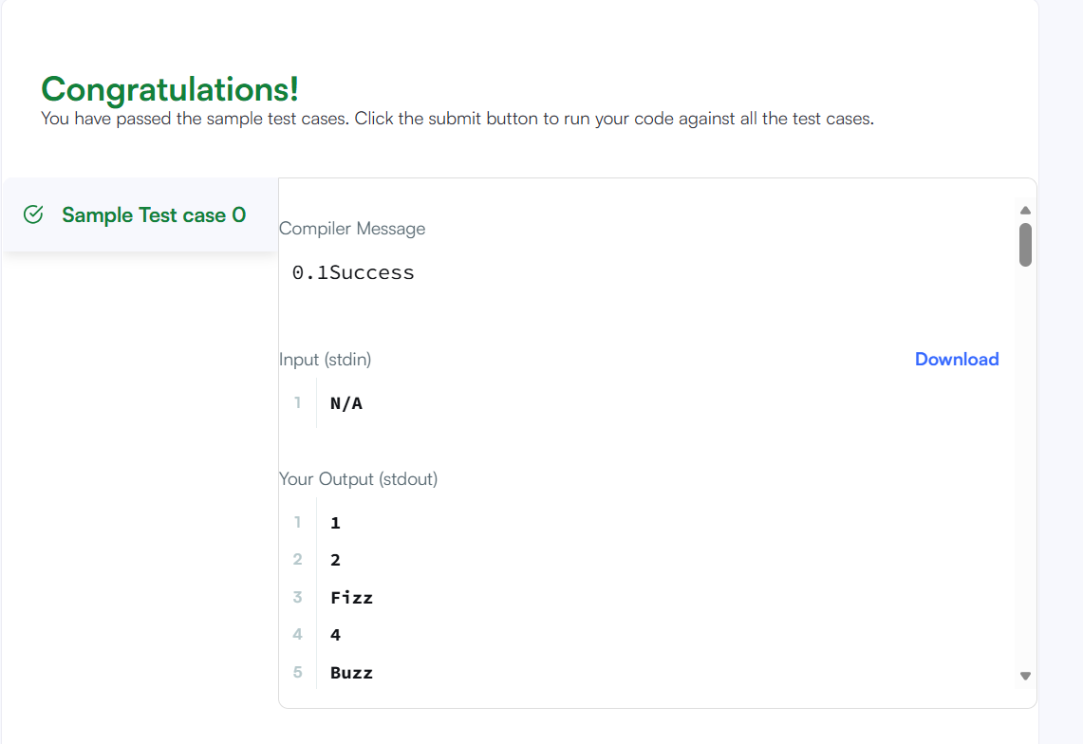Result
The program was executed successfully and produced the expected FizzBuzz output.

